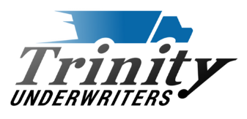 | Trinity Underwriters, LLC  (844) 392-0040



Important Changes Coming Soon

 | Effective 04/01/2024, a copy of the insured's Trailer Interchange agreement (or Amazon contract) must be provided before coverage can be bound or endorsed to an already existing policy.  If the insured does not have a Trailer Interchange agreement in place we will be able to offer a quote for Non-Owned Physical Damage.

Trailer Interchange vs Non-Owned Physical Damage

Trailer Interchange is intended to insure a total exposure of any and all trailers that could be pulled at any given time on any given day.  Coverage extends to damages while the trailer is in the insured's care, custody, and control. A Trailer Interchange agreement is required in order for their to be coverage. |  | Non-Owned Physical Damage does not require a written agreement to be in place. However, the trailer must be attached to a scheduled tractor in order for coverage to apply.

If you have any questions regarding this update please feel free to reach out to our underwriting department at quotes@trinityunderwriters.net.



Trinity Underwriters, LLC | 623 West Main St. Suite B | Clarkson, KY
www.trinityunderwriters.net | 844.392.0040

